**SELF-POWERED ZIGBEE WIRELESS SENSOR NODES FOR RAILWAY CONDITION MONITORING**

**ABSTRACT**

A track-borne energy transducer is a smart device for harvesting energy of trains or rail transportation systems. In this paper, the authors extend this application through introducing a self-powered ZigBee wireless sensor node. The proposed hardware prototype consists of a ZigBee coordinator at road-side and a series of sensors (Accelerometer, temperature sensor, humidity sensor, and infrared detector) connected to a ZigBee end device at rail-side. The ZigBee end device is powered by the magnetic levitation energy harvester and communicated wirelessly with the ZigBee coordinator. The magnetic levitation oscillator is selected due to its broad-band response characteristics. The results indicate a peak–peak output voltage of 2.3 V under the condition that the vehicle travels over the rail-borne device at the speed of 105 km/h.

**EXISTING SYSTEM**

RAIL transport, as a means of conveyance of passenger and cargo, plays an important role in our daily life. The building of rail infrastructure has experienced a sustainable growth in the past decade, especially in some developing countries. However, in remote area it is difficult to ensure power supply of rail-side monitoring equipment because wired power supply is not available for railways deployed in these locations. If we use wireless power supply such as batteries, it is also a big challenge for the maintenance and replacement of batteries in remote or inaccessible locations. It is therefore necessary to develop a new energy strategy. Actually, Germany has already engaged in covering more than one-third of its annual twelve billion kilowatt-hour energy requirement for the railway network with renewable sources by 2020. The saved energy is capable of powering wireless sensor networks (WSNs), which can be used for monitoring the railway infrastructure such as bridges, turnout, rail tracks, cuttings and tunnels, and track beds.

**EXISTING SYSTEM DISADVANTGE**

* Power supply problem of rail-side equipment.
* Money-consuming to deploy the railway monitoring system. It costs much to deploy traditional monitoring equipment.
* The wireless ones require batteries which can only work for a certain time period.
* The railway track is very long, cross remote or natural region, rendering the replacement of batteries impossible.

**PROPOSED SYSTEM**

The rapid development of semiconductor manufacturing process and large scale integrated circuit, Micro Electromechanical Systems (MEMs)-based sensor technique offers a low cost, low power, and integrated approach to structural healthy monitoring of railway track. ZigBee as low power consumption, low cost, limited data rate, and high reliable and secure communication protocol has well suited for the application of wireless sensor networks for railway condition monitoring. The objective of this paper is to solve the power supply problem of rail-side ZigBee devices and build up a self powered railway monitoring prototype with ZigBee protocol stack and magnetic levitation energy harvester. Compared with the WSN system powered by solar energy, the proposed solution is independent on the weather condition and can be used for both the railway transit in tunnel and the urban rail transit. Compared with the other vibration based energy harvesting solution, the proposed one is capable of energy harvesting at wide frequency range with small displacement amplitude, which fits the requirement of the vibration characteristics of the railway track. Section I of this paper presents the review of the state-of-the-art of track-borne energy harvester and application of ZigBee protocol in railway industry, which inspired the authors to conduct this study. Section II gives the principle of magnetic levitation oscillator and introduces the track-borne electromagnetic energy harvester, which is used to power the ZigBee devices. Hardwar prototype of ZigBee wireless communication module, together with selected monitoring sensor is introduced in Section III. A DC-DC booster converter is developed to convert the alternating input to a standard DC output. Analyzes the response of magnetic levitation harvester and reports the test results of the proposed approach.

**PROPOSED SYSTEM ADVANTAGE**

* Track-borne system can be used to vehicles by adding GPS module.
* The harvester could capture the vibration energy induced by the travelling loads of vehicle and charge the batteries.
* The long-term performance of the self-powered ZigBee sensor nodes for the railway condition monitoring

**BLOCK DIAGRAM**

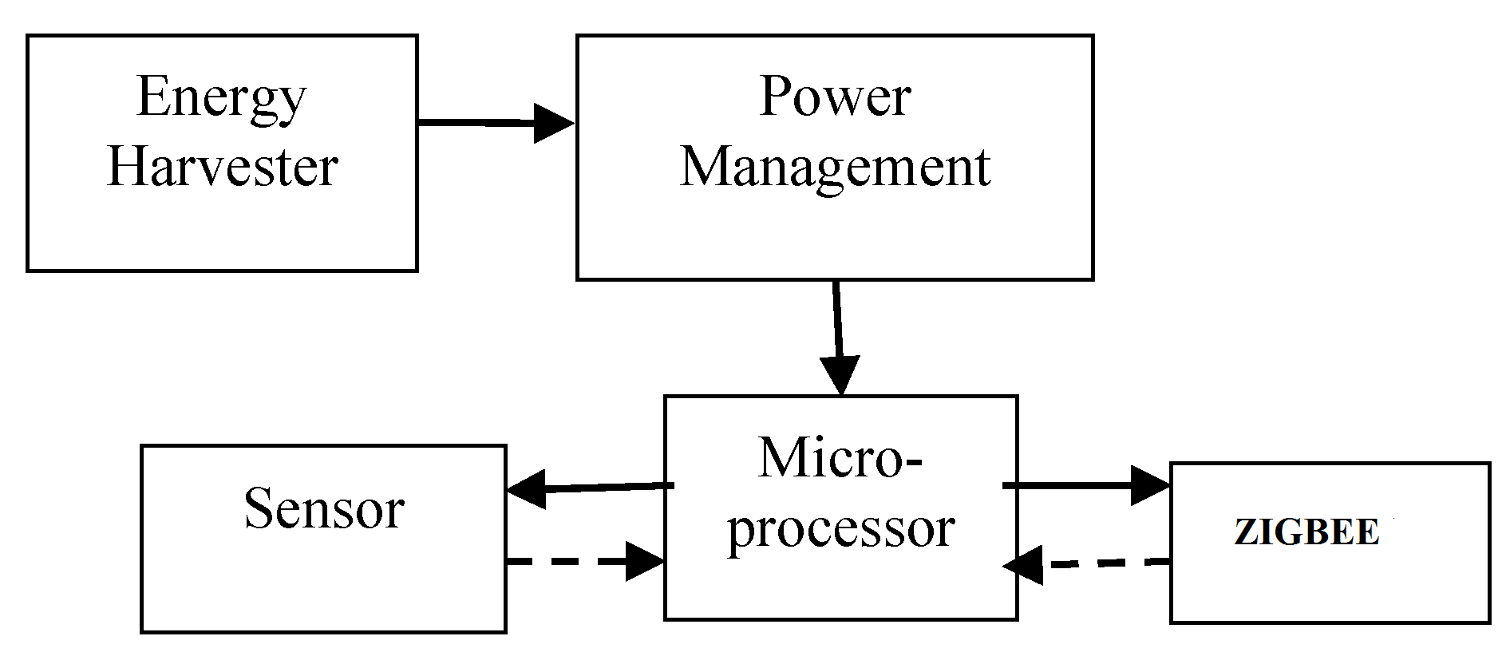

**HARDWARE REQUIREMENT**

* Arduino
* Zigbee
* Accelerometer
* Temperature sensor
* Electromagnetic device